Module 5

Loop

The Loop block allows you to repeat blocks under all different kinds of conditions.

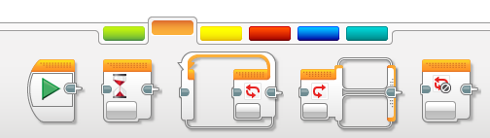

By default it is set to loop forever and named “01”.

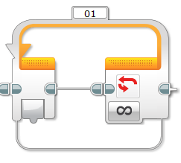

The option on the end can be selected to change when the loop ends.



# Activity 1 – Make a Square

In Module 3 – Moving your Robot, you learnt to turn at 90 degrees.

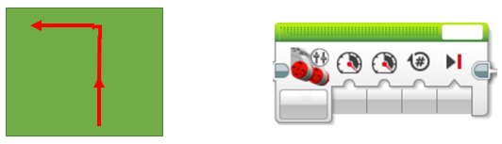

Use the same blocks to create a square shape.

*Hint: You will need a total of 8 blocks, 4 to go straight and 4 to turn.*

# Activity 2 – Square with a Loop

The loop allows you to repeat blocks. In Activity 1 the square is made up of 4 groups of 1 straight than 1 turn.

1. Only use 2 action blocks inside a loop that counts 4 times. Use the “Count” mode of the loop to do this.
2. Put your counting loop inside another loop which either goes forever or counts a number of squares. Now you can tell the robot how many squares to make.

*Hint: Count Mode is underneath the Unlimited Mode.*

# Activity 3 – Loop

## Loop Interrupt

A block related to the loop block is the “Loop Interrupt”. This will allow you to end a loop by its name. You will see this in the tutorial.

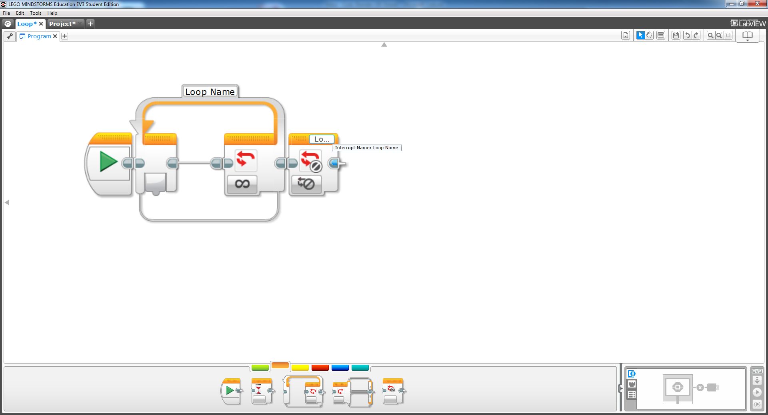

## Tutorial

Open up and complete the tutorial project Robot Educator 🡪 Beyond Basics 🡪 Loop.

There are 2 new blocks in this tutorial:

* Sound
* Brick Status Light

We will cover these in more detail later but feel free to play with their settings.

